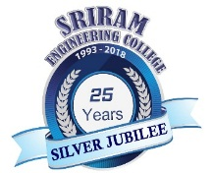

SRIRAM ENGINEERING COLLEGE

(A unit of Sriram Educational Trust)

Approved by AICTE,New Delhi & Affiliated to Anna University,Chennai

22nd Graduation Day on 30th June 2019 (Sunday) at 11.00 a.m

REGISTRATION FORM
[For Confirmation of participation]

Name :

University Register Number :

Branch :

Batch :

Mobile No. :

E-mail id :

No. of Accompanying Guest :
(Not exceeding two)

- All those not attending, will receive their degree “in Absentia”, and can collect their degree certificate from the college office after 30th June 2019. They will not be provided seating on the Graduation Day in the Auditorium.

